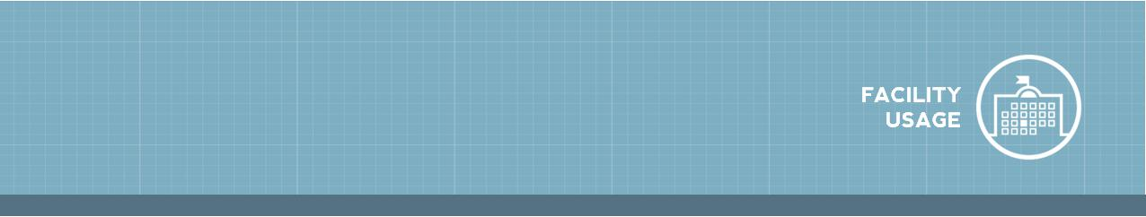**CommunityUse Requester Guide**

1

**How to Log in**

* Go to <https://www.communityuse.com/default.asp?acctnum=903810048>
* At the top of the page, click on the **Login to Request Facility Use** link.
* If you have already registered, enter your login name and password into the fields and click **Log** **In**.
* Once you are logged in, the system will default you to the home page where you can view the calendar. *\*Note: If no events are showing on the Calendar, be sure you have a* ***Location*** *selected. Any time you make a filter choice on the Calendar, click the* ***Filter*** *button to refresh the screen.*

**How to Submit a Request**

* Click on the **Request Facility Use** tab. *\*Note: If this is your first time making a request through* *CommunityUse, you will be asked to read the terms and conditions that the district provides. You will also be asked to verify that you agree to these terms each time you submit a request.*
* Choose the type of schedule you would like to submit.
* A **Normal Schedule** can be for a single date or multiple dates, but each event will be in the same location and room at the same time of day. You can request up to a maximum of 20 dates on a normal schedule.
* The **Recurring Schedule** is used for an event that takes place on a regular basis (Example: every Monday and Wednesday from October through December). These events will also be in the same location and room at the same time of day. You can enter up to a maximum of 100 dates on a recurring schedule.

**NEW Facility Use Request Wizard**

*Note: Any field marked with an orange line is a required field.*

**Step 1 - Search**

* Enter the **Event Title**.
* Enter an **Event Description** of the event you are requesting.
* Select the **Location** and **Room(s)** you would like to reserve for your event.
* 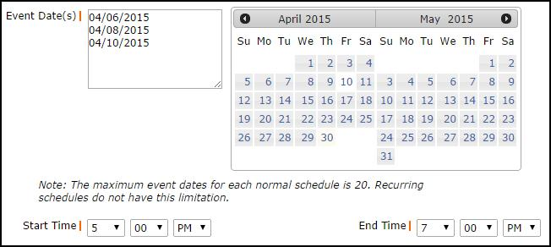If entering **a Normal Schedule**:
* Enter the **Event Date(s)** by typing into the box or clicking on the dates in the calendar box to the right.
* Enter the **Start Time** and **End Time**, making sure to select AM or PM in the drop down boxes.

|  |  |
| --- | --- |
| **CommunityUse Requester Guide** | 2 |



  If entering a **Recurring** **Schedule**:

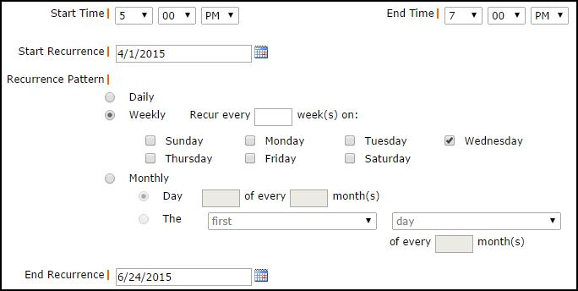

* Enter the **Start Time** and **End Time**, making sure to select AM or PM in the drop down boxes.
* Enter the **Start Recurrence** date.
* Choose your **Recurrence Pattern**.
* Select **Daily** if your event will occur every day between the start and end dates.
* If you choose **Weekly**, you can select if the event occurs every week, every 2 weeks, etc. Then put a check mark next to the days of the week that the event will occur.
* If you choose **Monthly**, you can select the day of the month (for example, the 15th day of every 1 month) or you can choose the weekday of the month (for example, the second Monday of every 1 month).

  Enter the **End Recurrence** date.

  Click on the **Search** button to make sure that the room you are requesting is available.

**Step 2 - Availability**

* Your requested rooms will show at the top, and the time frame you’ve requested will show in yellow. If you see a black or red x in the box, there is already an event scheduled at that time.
* If the selected rooms are available at your desired time, click **Next** to proceed with your request.
* To change the room, date, or time of your request, click **Previous** to make new selections.

**Step 3 - Event Details**

**Additional Information**

* This section may or may not appear on your request form depending on how your Administrators set up your account.
* If this section does appear on your form, answer the available questions providing additional information for your event.

**Organization Information**

* Select your **Organization** that is requesting the facility from the drop down menu.
* Select the **Contact** in drop down box.
* If you need to purchase a short term insurance certificate for your event, follow the links included in this section.

**Services**

  The Services feature may or may not be available on the form.

|  |  |
| --- | --- |
| **CommunityUse Requester Guide** | 3 |



**Setup Requirements**

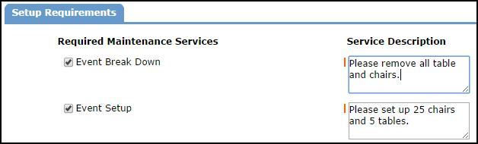

* If **Maintenance Services** or **IT Services** are needed for your event check the box next to the service needed and enter a **Service** **Description** in the box.

**Rental Requests**

* If there are rental items available in this section, select the ones needed for your event, enter the

**Quantity**, and write a **Rental Description**.

**Event Information**

* Enter **Total Attending**. You can also break this number into number of adults and number of children.
* Enter the number of **Extra Chairs Required** for the event.
* Enter the number of **Parking Spaces Required** for the event.
* Check the **Yes, please display events on** **the community calendar** if you would likethis event to appear on the calendar.
* Enter any **Other Needs** if needed.

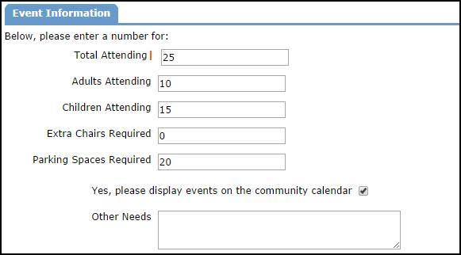

**File Attachments**

* Attach a file to your schedule request by clicking the **Add New File** link.
* Browse your computer for the file and select it. You can also enter a **File Description**. Click

**Submit**.

* The attached file will now be listed in the File Attachments section at the bottom of the schedule. *\*Note: There is no limit to the number of files that can be attached; however the total size of all uploaded files on the schedule must be less than 5MB.*

**Signature**

* Enter your email address in the **Signature** box.
* Check the box confirming that **I confirm that I have previously read and agree with the terms** **and conditions of facilities use**.
* Click **Save** to submit your request.

**Step 4 - Confirmation**

The Confirmation page will give you the Schedule ID number for your request and a summary of the event information. You can print this page for your records.

|  |  |
| --- | --- |
| **CommunityUse Requester Guide** | 4 |



**My Requests Tab**

* On the My Requests Tab, you can view a list of your previously submitted schedule requests as well as **View Invoices**.
* If your account is set up to take online payments, you will see a **View Invoices & Pay Online** link that will allow you to make invoice payments online.

**My Organizations Tab**

* On the My Organizations tab you can review the Organization(s) that you have been approved to submit requests for.
* Clicking the Organization Name will take you to the Organization Information page where you can verify the Address and other important information including Insurance Information. Please contact your CommunityUse Administrator if any of the information is inaccurate or out of date.
* If you need to request events for another organization click on the **Request Another** **Organization** link to submit a request to be added to that organization.

**My Settings Tab**

* On the My Settings tab you can update your personal contact information or reset your password.
* Be sure to click **Submit** to save any changes.

**Documents Tab**

* On the Documents tab, you can download any documents that Administrators have posted for community users to view.